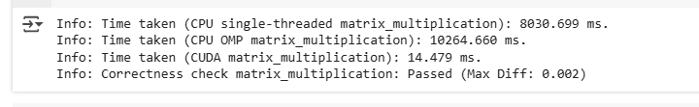  
  
For specs: COlab T4 GPU was used.